**CHATBOT DEPLOYMENT WITH IBM CLOUD WITH WATSON ASSISTANT**

**IBM CLOUD :**

IBM Cloud is a suite of cloud computing services provided by IBM. It offers a variety of infrastructure as a service (IaaS), software as a service (SaaS), and platform as a service (PaaS) solutions. IBM Cloud provides a range of services, including computing power, storage solutions, and various AI and machine learning tools.

Some key features of IBM Cloud include:

**1. Compute Services:** This includes virtual servers, containers, and serverless computing options.

**2. Storage Services:** IBM Cloud offers various storage solutions, including object storage, block storage, and file storage.

**3. Database Services:** Different types of databases, such as relational databases, NoSQL databases, and in-memory databases, are available on the IBM Cloud platform.

**4. AI and Machine Learning:** IBM Cloud provides services and tools for artificial intelligence (AI) and machine learning (ML), allowing users to build, train, and deploy models.

**5. Blockchain:** IBM Cloud supports blockchain technology, enabling users to build and deploy blockchain networks.

**6. IoT (Internet of Things):** IoT services on IBM Cloud help connect and manage devices, collect and analyze data, and integrate IoT solutions into various applications.

**7. DevOps and Tools:** IBM Cloud includes tools and services that support DevOps practices, allowing for seamless development, testing, and deployment of applications.

**8. Security and Compliance:** IBM Cloud places a strong emphasis on security and compliance, offering tools and features to help users secure their applications and data.

**CHAT BOT :**

A chatbot is a computer program designed to simulate conversation with human users, especially over the Internet. Chatbots use natural language processing (NLP) to understand and respond to user inputs in a way that mimics human conversation.

Here are some key aspects of chatbots:

**1. Natural Language Processing (NLP):**This is a key technology that enables chatbots to understand and interpret user input in natural language. It involves the ability to analyze and comprehend the meaning of text or speech.

**2. User Input and Output:** Chatbots interact with users through text or speech. Users input their queries or requests, and the chatbot responds accordingly. Some advanced chatbots can also process multimedia inputs like images or videos.

**3. Types of Chatbots:**

**Rule-Based Chatbots:**These chatbots follow predefined rules and patterns to respond to user inputs. They are limited to the specific rules set by their developers.

**AI-Powered Chatbots:**These chatbots use artificial intelligence and machine learning to improve their responses over time. They can learn from user interactions and adapt to new patterns.

**4. Use Cases:**

**Customer Support:** Chatbots are commonly used for providing instant responses to frequently asked questions and guiding users through troubleshooting processes.

**E-commerce:**Chatbots can assist users in finding products, placing orders, and answering questions about products or services.

**Information Retrieval:** Chatbots can be designed to fetch information from databases, websites, or other sources based on user queries.

**5. Platforms:** Chatbots can be deployed on various platforms, including websites, messaging apps, and social media platforms. They can operate in both public and private spaces, depending on the application.

**6. Integration with APIs:** Chatbots often integrate with external APIs (Application Programming Interfaces) to access additional data or perform specific actions, enhancing their functionality.

**7. Development Tools:** There are several tools and frameworks available for developing chatbots, ranging from simple rule-based systems to sophisticated machine learning-based approaches. Some popular platforms include Dialogflow, Microsoft Bot Framework, and Rasa.

Chatbots have become increasingly popular as businesses seek efficient ways to interact with users, provide instant support, and automate routine tasks. They continue to evolve with advancements in NLP and AI technologies.

**Img 1 :** Sample of conversation of chatbot

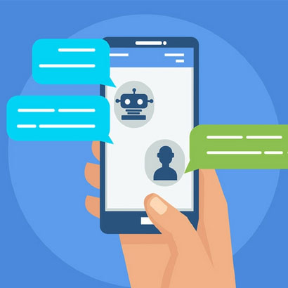

**IBM CLOUD ACCOUNT :**

**Database Setup:** Create an IBM Cloud account, choose the appropriate database service like db2, and set up a database instance.

**Steps followed to create IBM Cloud Account.**

**Step 1 -** Go to [myclass.skillup.online](http://myclass.skillup.online) platform and search Introduction to cloud.

**Step 2 -** Then Go to Module 1 and click the obtain feature code to obtain the feature code. Then click to activate the account.

**Step 3 -** Then you will be redirected to the [cloud.ibm.com](http://cloud.ibm.com) and then type our registered email id and password.

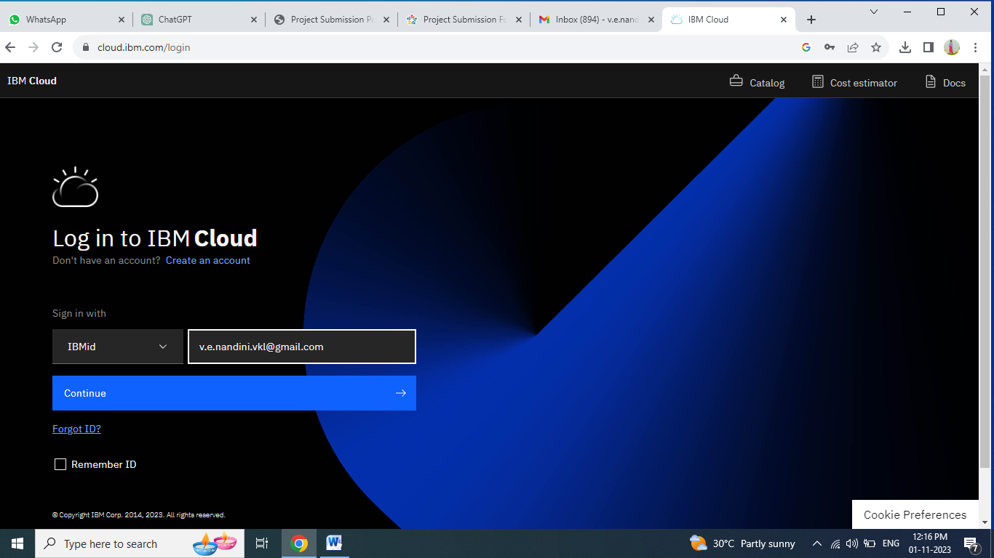

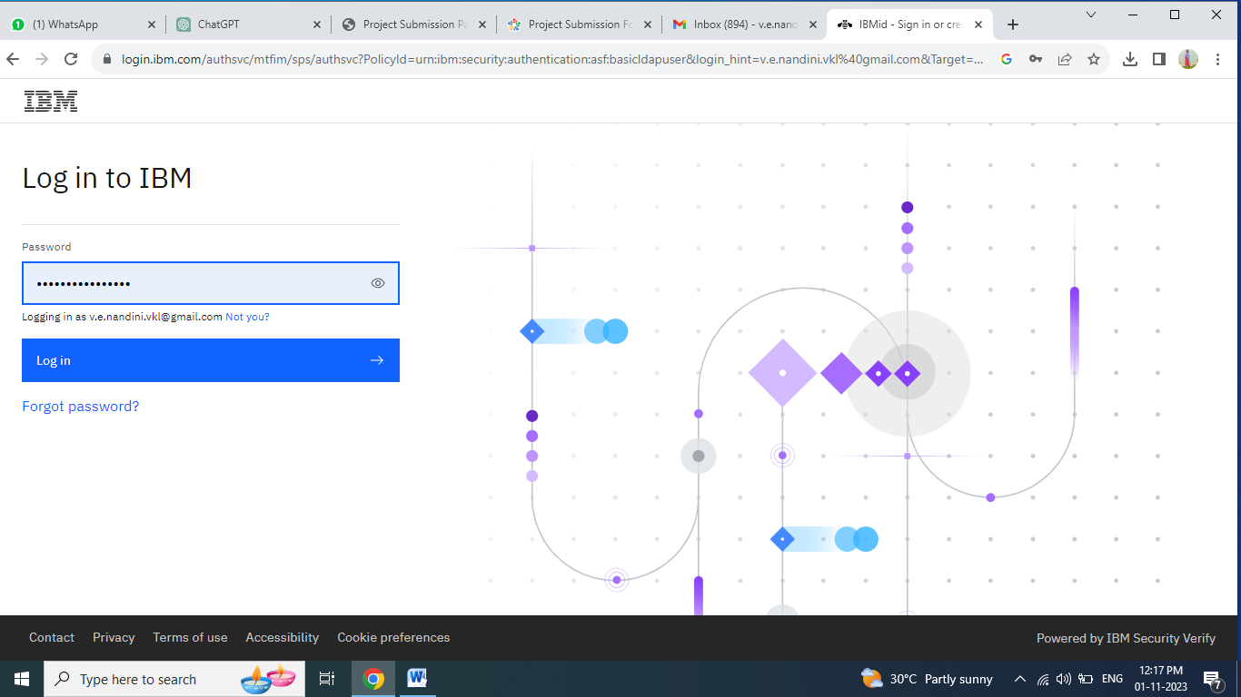

**Step 4 -** Then you will be redirected to the dashboard.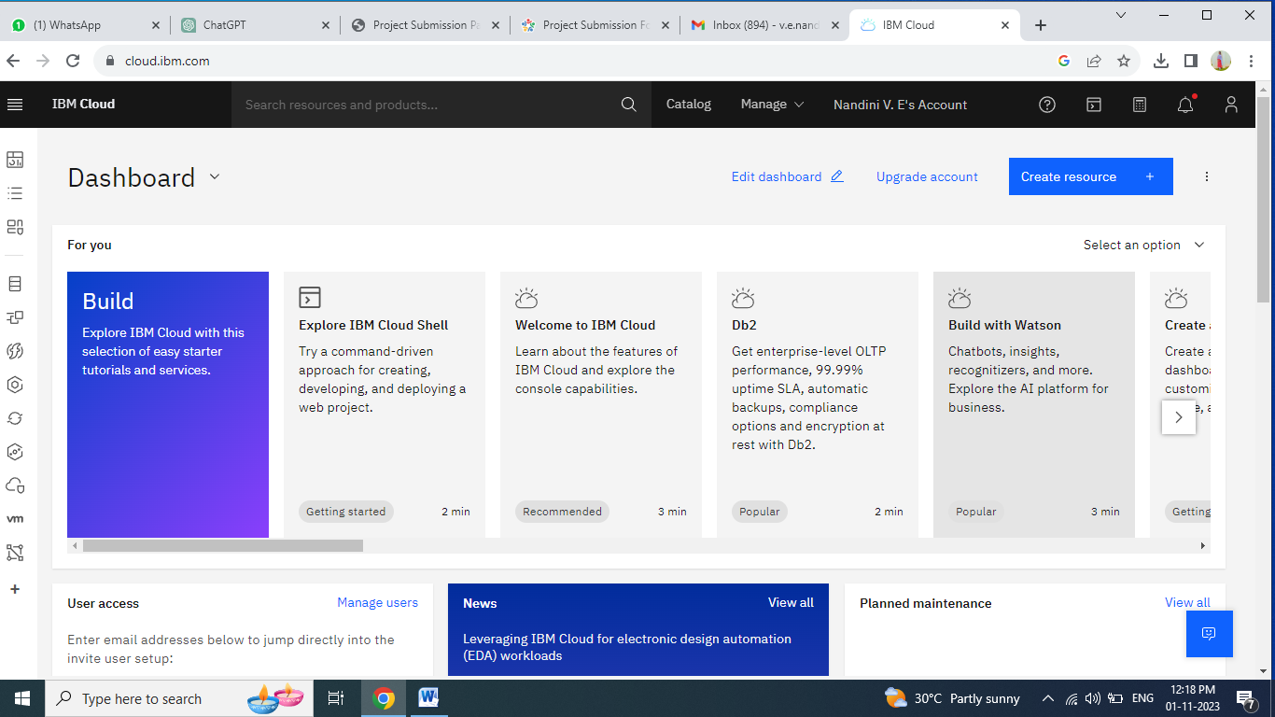

**Step 5 -** Then you should go to catalog and choose Watson Assistant.

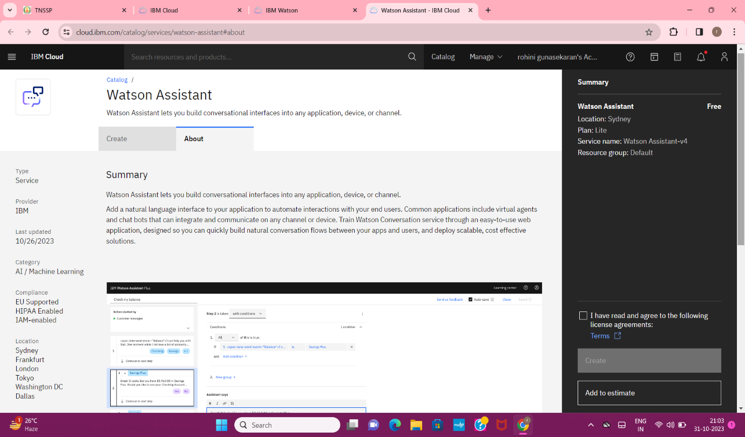

**Step 6 :** stepby step procedure of creating the Watson chatbot using IBM cloud account.

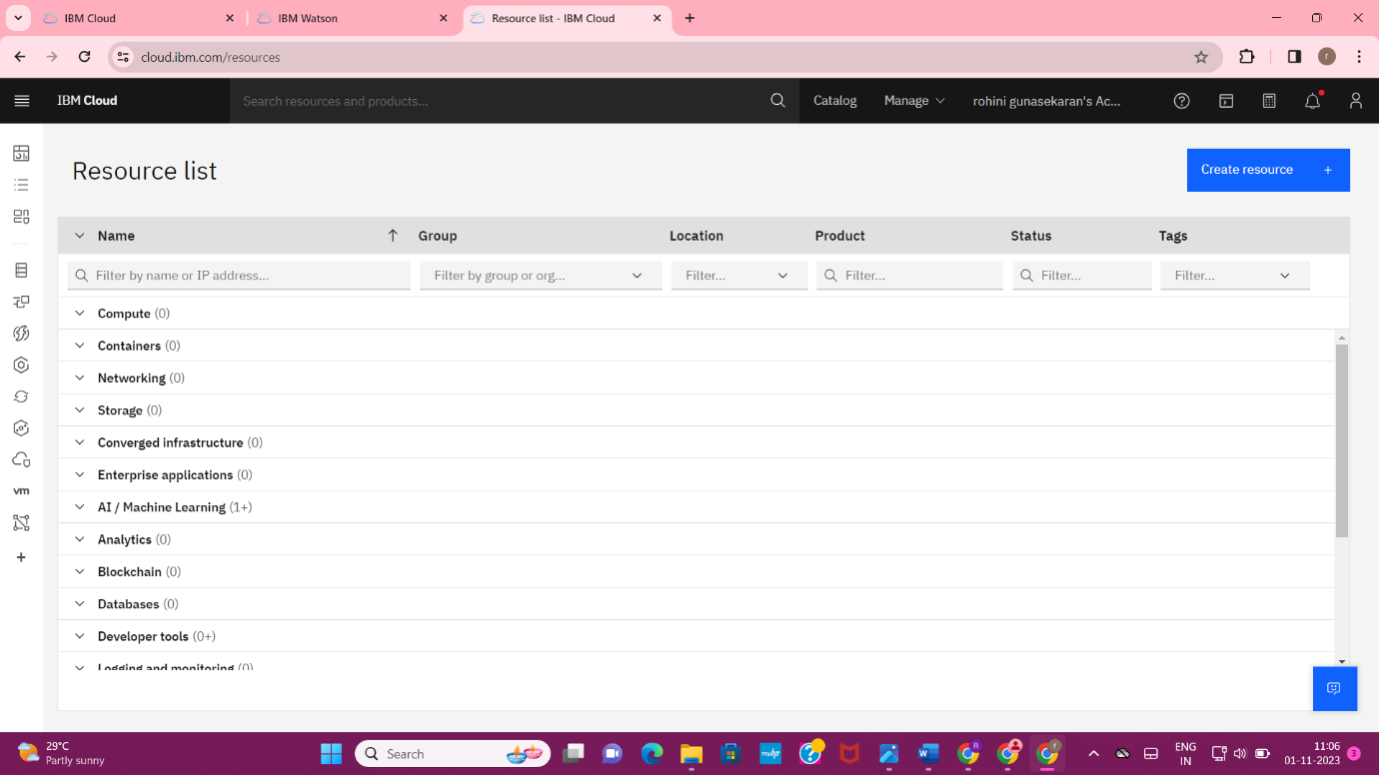

**Step 7:** Assigning a name for the Watson assistant chatbot .

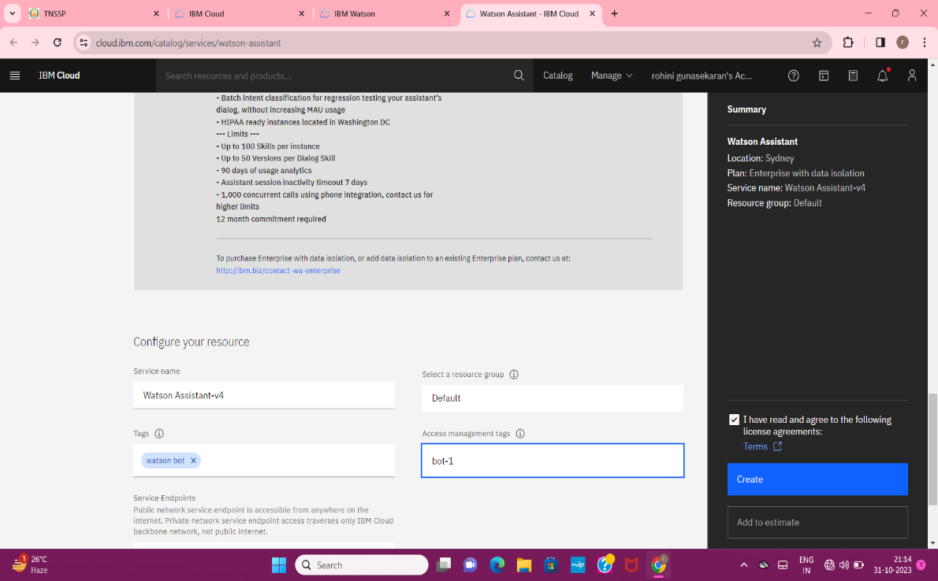

**Step 8:** Launching the Watson assistant

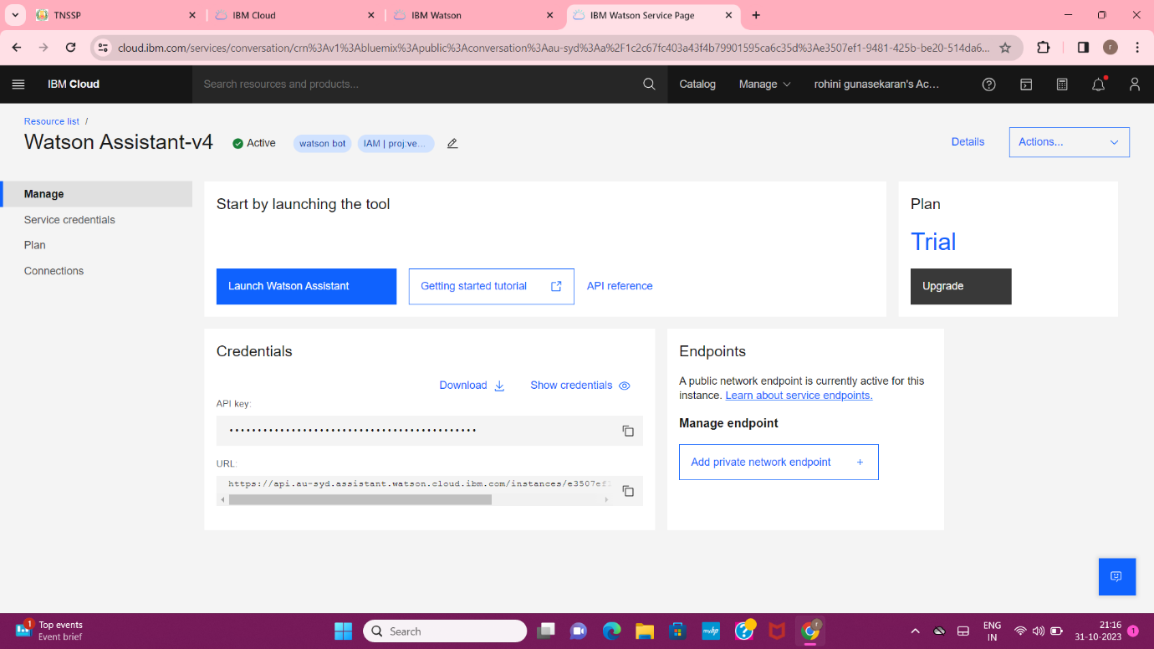

**Step 9:** Creating the assistant by adding the details of Watson Assistant Chatbot.

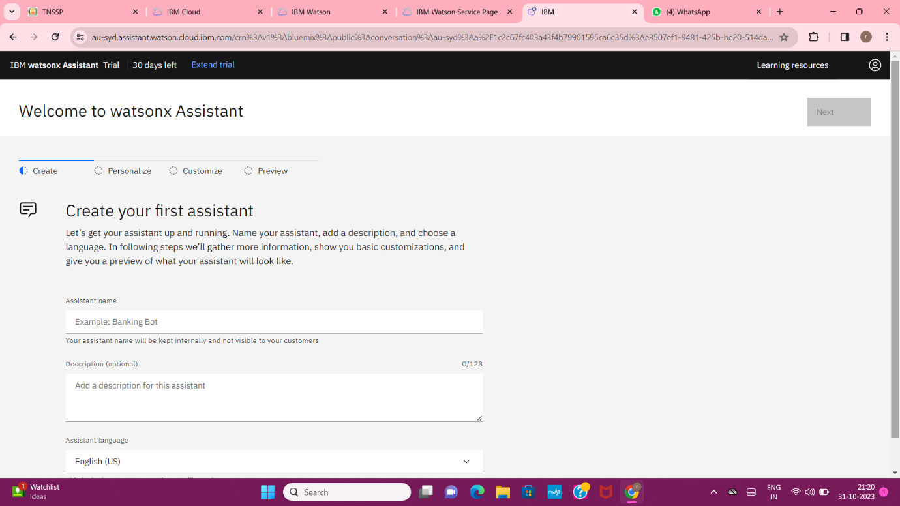

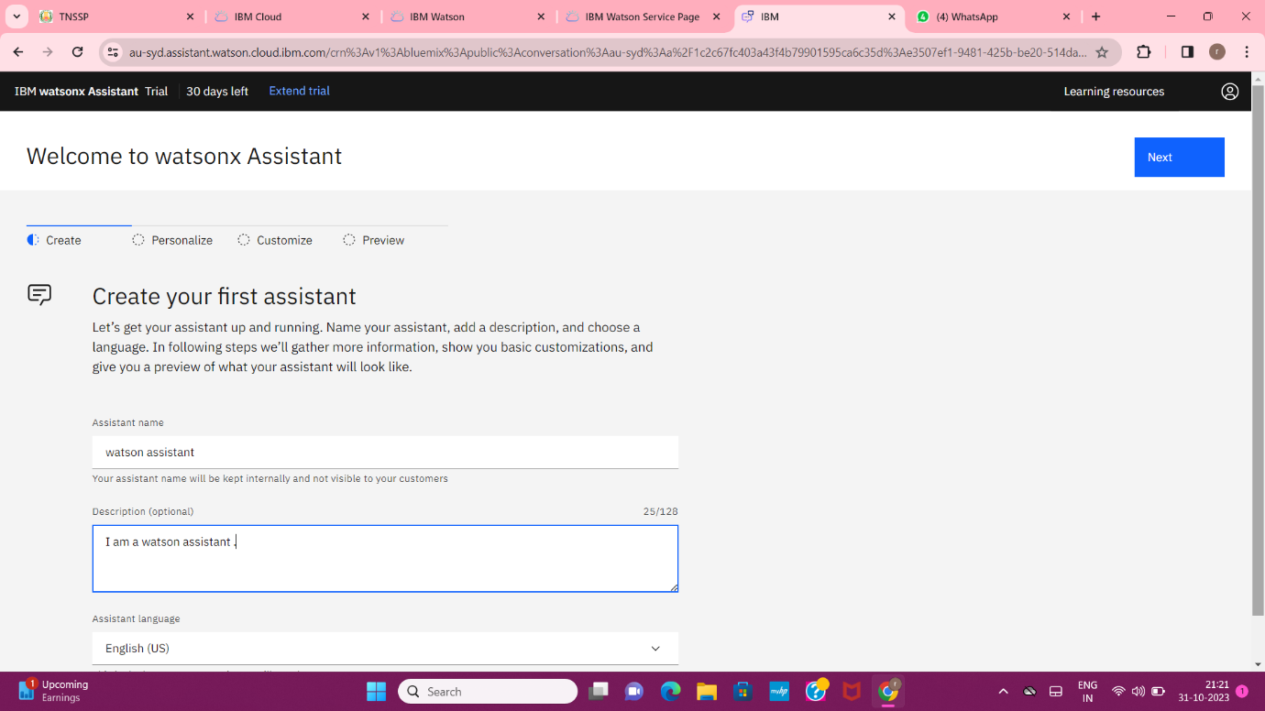

**Step 10:** Personalise our Watson Assistant Chatbot. (choosing the templates of our Watson Assistant Chatbot).

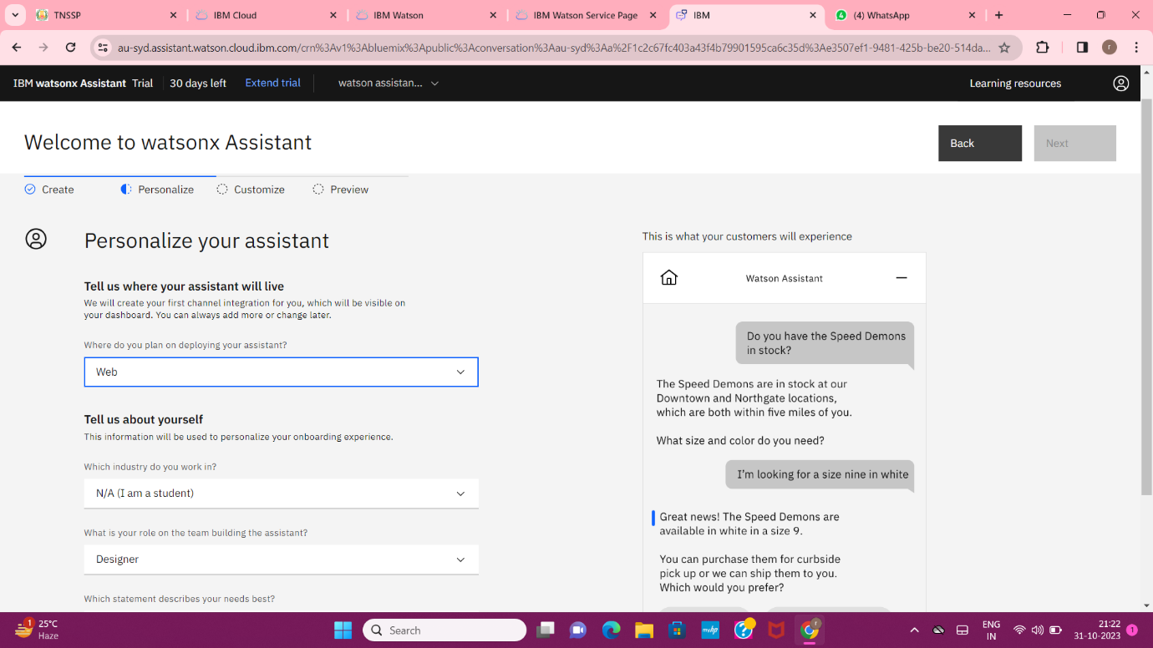

**Step 11:** Customize our Watson Assistant Chatbot with UI.

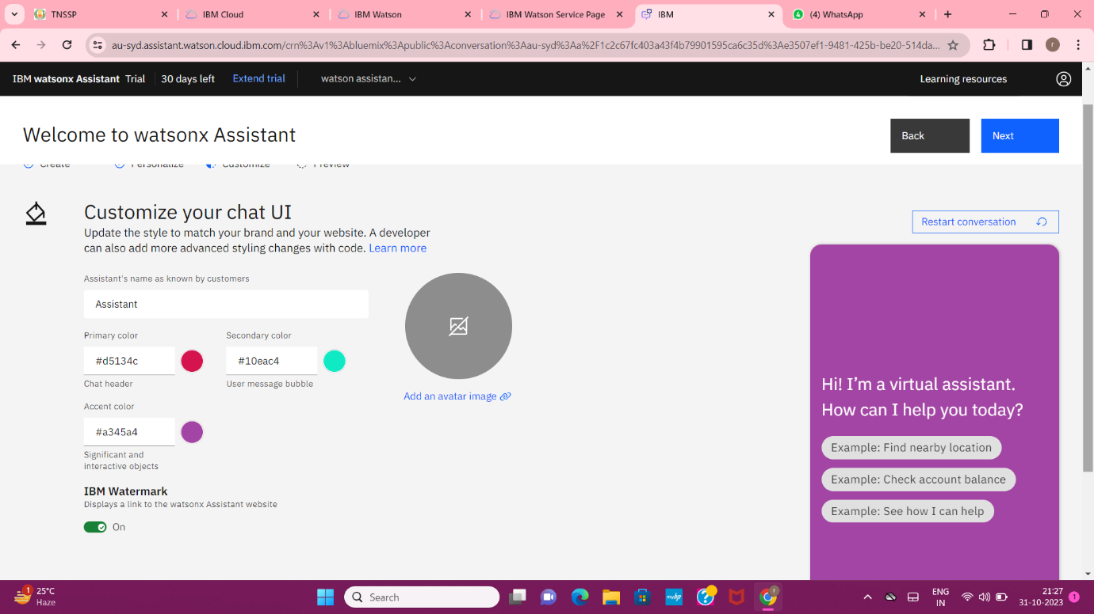

**Step 12:** Preview our Watson Assistant Chatbot **.**

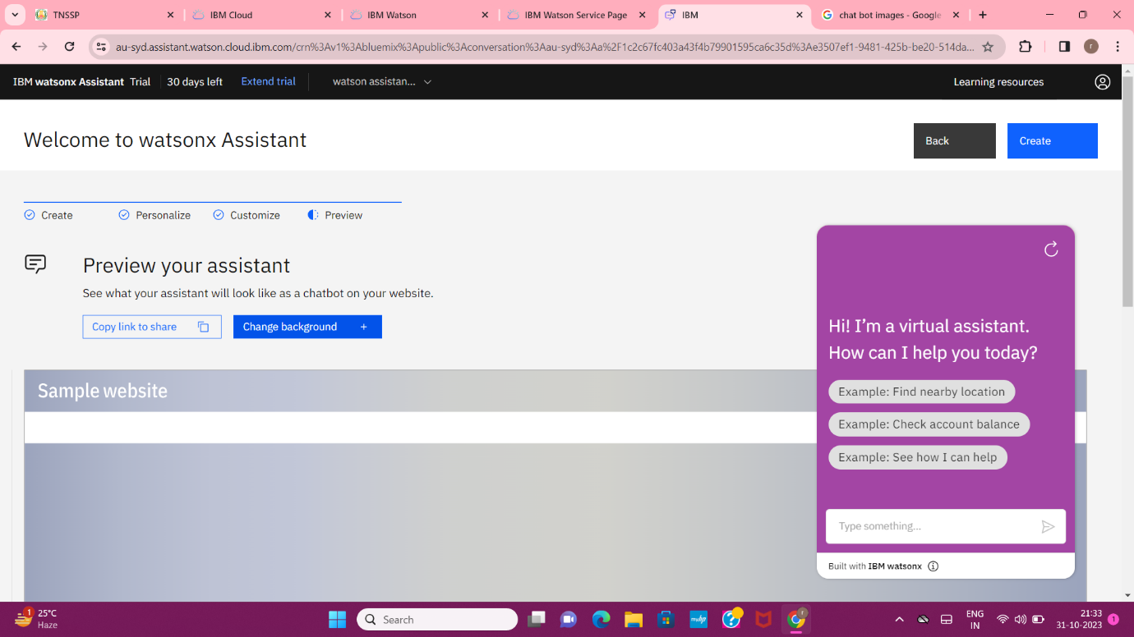

**Step 12.1 :** Adding the background image .

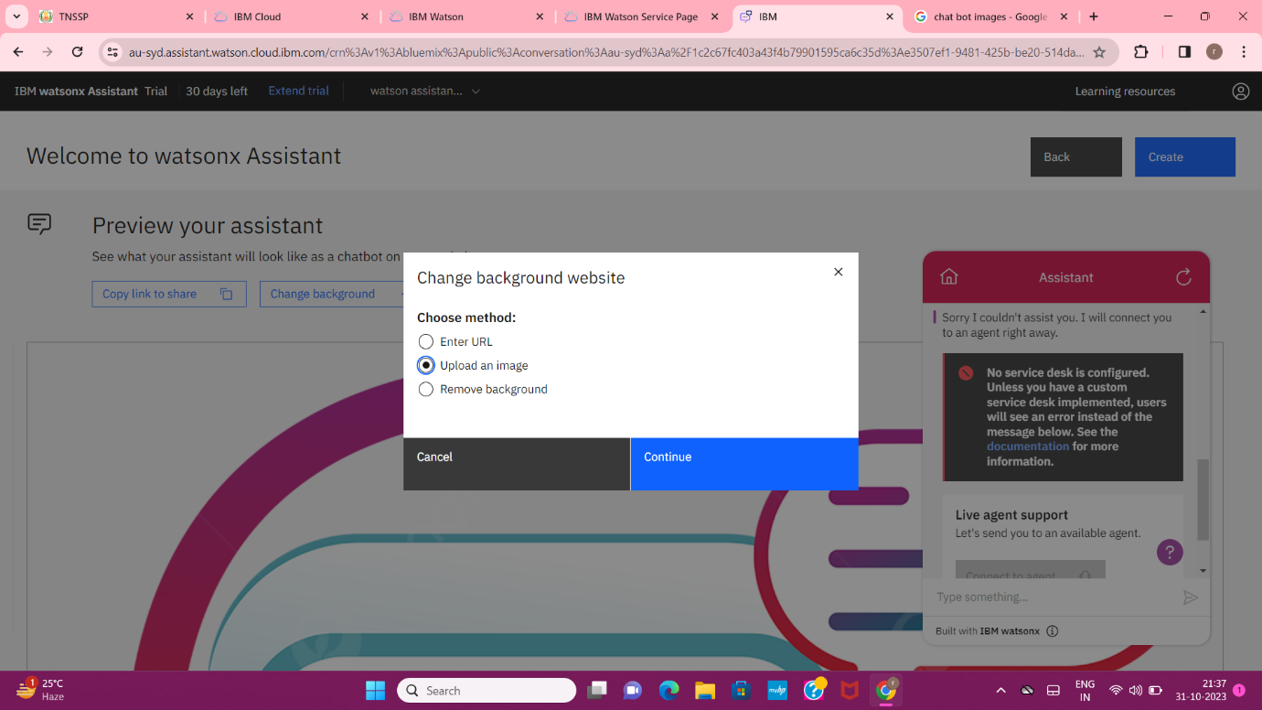

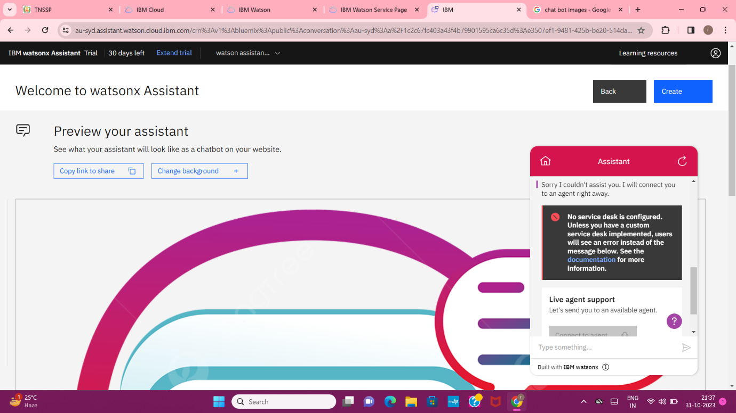

Uploaded the background image to our chatbot.

Image of completion of building Watson Assistant Chatbot of personalize, customize and preview.

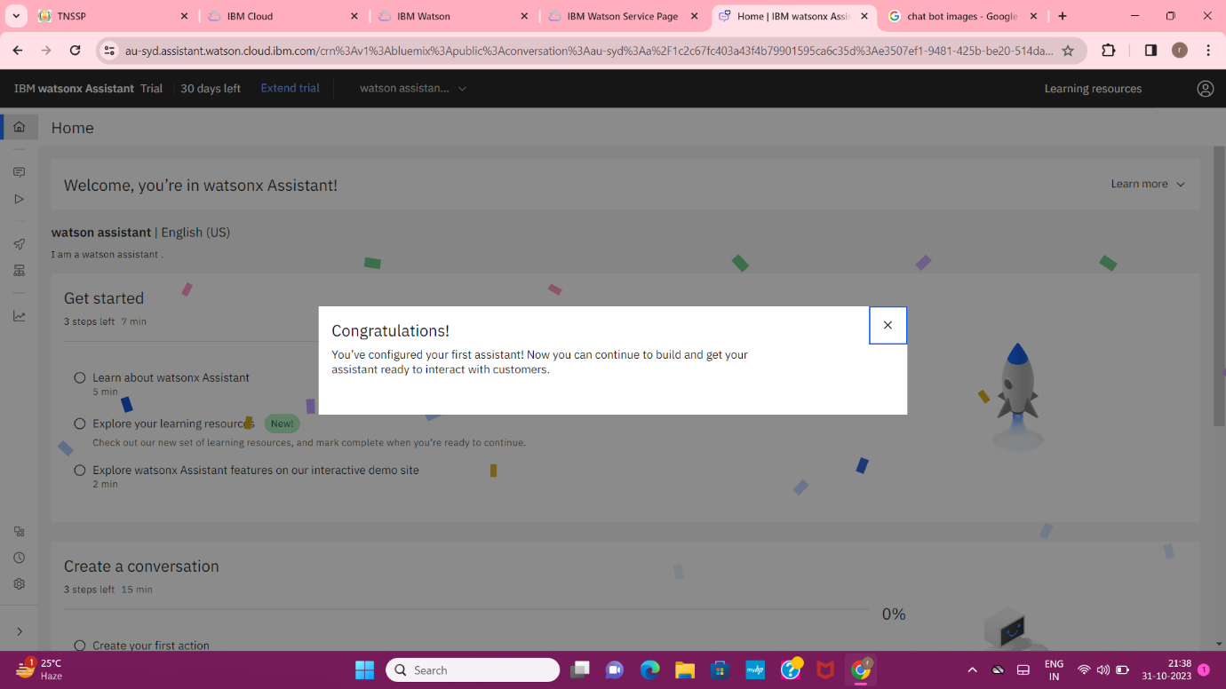

**Step 13** : Building the questions and answers to the Watson Assistant Chatbot.

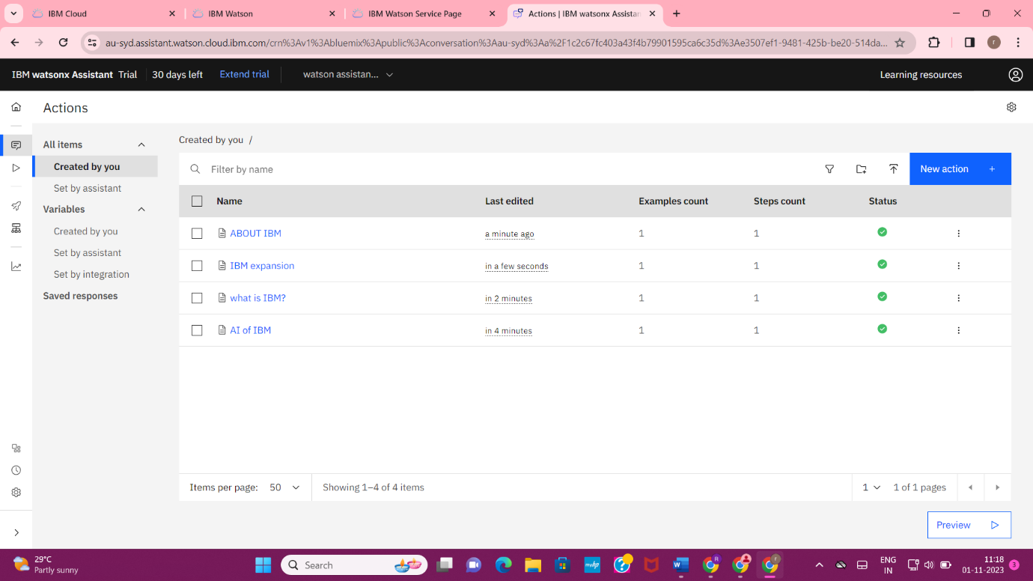

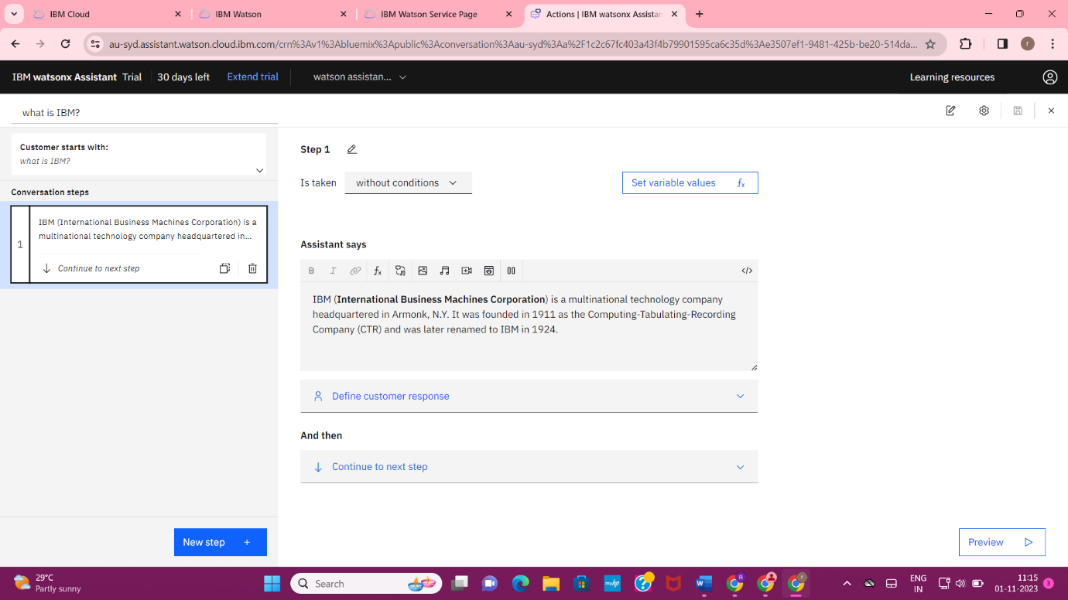

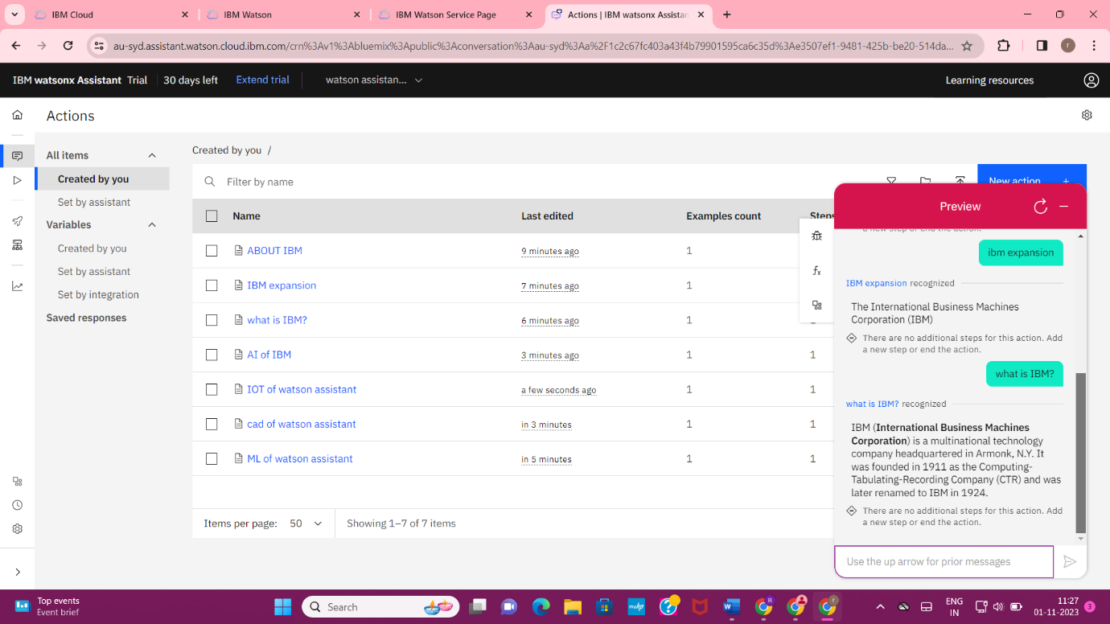

**Step 14 :** Copy the link for the Watson Assistant Chatbot.

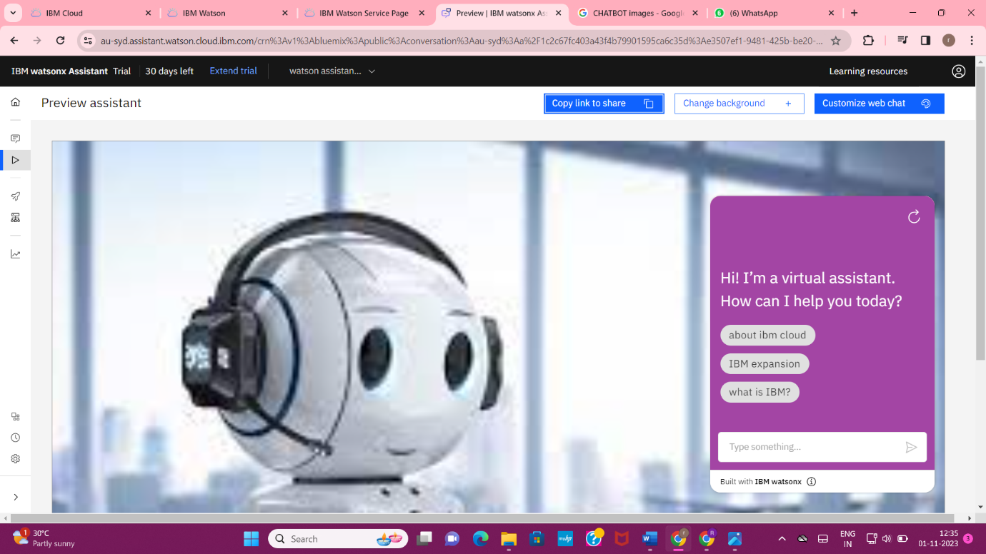

**LINK of Watson Assistant Chatbot :**

<https://web-chat.global.assistant.watson.appdomain.cloud/preview.html?backgroundImageURL=https%3A%2F%2Fau-syd.assistant.watson.cloud.ibm.com%2Fpublic%2Fimages%2Fupx-e3507ef1-9481-425b-be20-514da6dcdd05%3A%3A8724d29c-771c-4f25-b3d1-09598fe951b7&integrationID=2d22670c-c333-4aa2-a12a-9af66d86a5eb&region=au-syd&serviceInstanceID=e3507ef1-9481-425b-be20-514da6dcdd05>

**Sample screenshot of using Watson Assistant Chatbot In Mobile Phone by using the link of chat bot which is created by using the Watson Assistant of IBM Cloud.**

**Image 1:** 1st page of Watson Assistant Chatbot

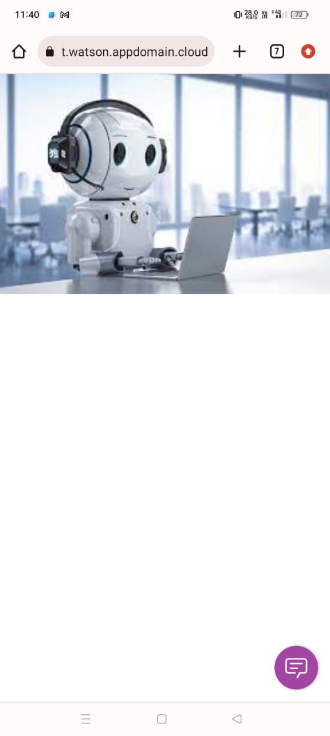

**Image 2 :**

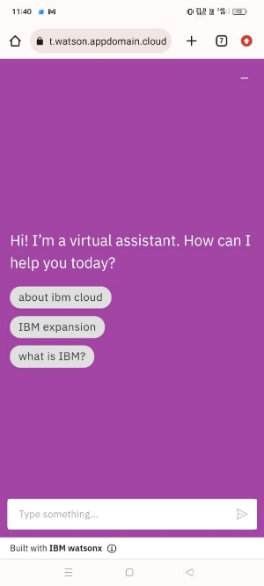

**Image 3 :** Conversations of chatbot .

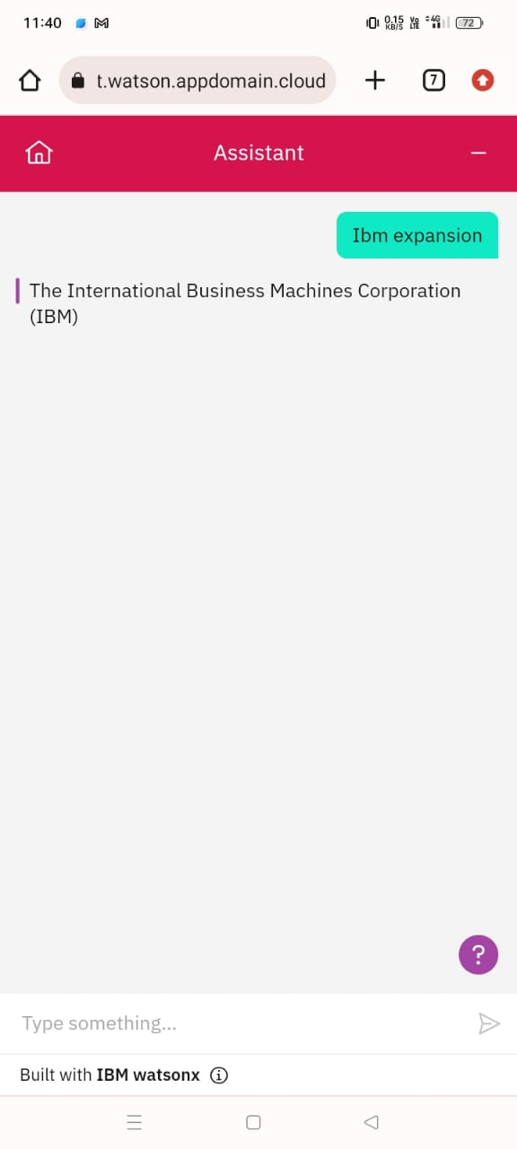

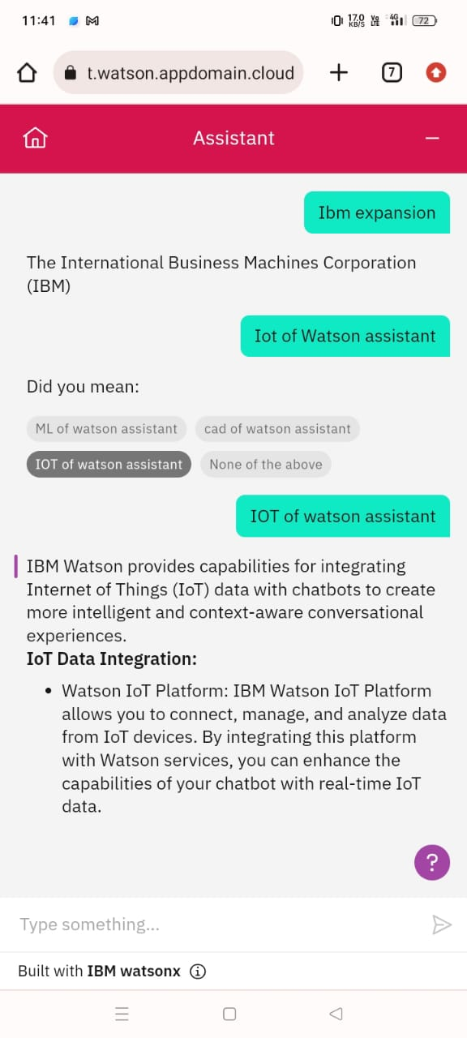

**Finally Watson Assistant Chatbot has been created by using IBM Cloud .**